GILE Journal of Skills Development

The Significance of Social Media in Crisis Management for the Hospitality Industry

Anna Maria Wantoch-Rekowski
XU Exponential University of Applied Sciences, Potsdam, Germany
- ORC ID: Leave this do not remove.

Prof. Dr. Petyo Budakov
XU Exponential University of Applied Sciences, Potsdam, Germany
- ORC ID: Leave this do not remove

Abstract
In our progressively digital society, the hospitality industry has experienced a paradigm shift in its marketing and communication strategies. The challenges caused by the corona crisis, especially from an economic point of view, led to business failures and risked the existence of many companies. The corona crisis had a huge impact on the economy, with losses of billions of euros being reported. This article will examine the evolving role of social media and its relevance to the hospitality industry in terms of crisis. Specifically, it will examine how social media platforms have become indispensable tools for maintaining brand presence, engaging with guests, and navigating through turbulent times, with a special emphasis on the challenges posed by the corona crisis. By leveraging social media effectively, hospitality businesses can not only weather crises but also emerge stronger and more resilient. The study will explore various strategies employed by hospitality companies on social media, including crisis communication tactics, customer engagement initiatives, and reputation management efforts. Furthermore, the article will discuss the long-term implications of the corona crisis on the hospitality industry's digital transformation journey. From accelerating the adoption of technology to reshaping consumer expectations, the crisis has underscored the importance of digital resilience in an increasingly volatile world. By thoroughly examining the intersection of social media and crisis management in the hospitality sector, this paper aims to contribute to the body of knowledge in both academic and practical domains. As businesses continue to navigate uncertainties, understanding the evolving role of social media in crisis communication and brand management will be essential for survival and success.
Keywords/key phrases: Social Media, Hospitality Industry, Crisis Management, Relevance, Marketing Strategies, Risk Management.
- Introduction
In the context of the corona crisis, Germany experienced two phases of lockdown. The society followed guidelines set by the national government to manage this crisis. Measures such as maintaining physical distance, wearing protective masks, and consistently following hygiene standards were established as key guidelines. During the lockdown periods, social contact was drastically limited, forcing people to stay in their houses and not to interact personally, not even with close friends and family members. (Lorenz, 2021, p. 11)
Consequently, numerous hospitality companies found themselves in a threatened existential situation. A survey by the German hotel and restaurant association showed that 58.6 percent of hospitality companies in Germany feared for their existence after the second lockdown. That is because the second lockdown in November resulted in a loss of 50 percent in sales in January compared to January 2019. (rnd, 2022b)
The number of gastronomy businesses that are financially vulnerable and therefore at high risk of insolvency has increased by nearly one-third to 16.2 percent from January 2020 to January 2022 (rnd, 2022a). The companies were forced to react and follow the measures prescribed by the government. In the hospitality industry in particular, restaurants rapidly implemented delivery services or adapted their operating models. Many of them also took the step to use social media to acquire customers and make the transition from humanitarian communication to digital communication. Unfortunately, not all companies have seen the relevance of social media as a crisis communication tool. Already in 2019, not even half of German companies used social media as a tool for customer acquisition (Destatis, 2020).
This leads to the problem that the hospitality industry has not yet sufficiently recognized the importance of social media as an effective communication tool in times of crisis and subsequently. However, this is a crucial factor to be competitive in future crisis situations or to manage the crisis successfully at all.
4. Methodology
In the following, the methodological approach within the framework of this scientific research will be described in more detail. After a description of the quantitative social research, the development of the questionnaire will be presented. Following this, the selection of the research group and the quality criteria of quantitative social research will be discussed. After the topic of the quantitative social research was clarified, the qualitative social research will be described. Subsequently, the creation of the interview guideline will be explained. Afterwards, the selection of the interview partners will be explained and the aspects concerning the preparation and execution of the interviews as well as the processing of the results will be explained. Finally, the quality criteria of qualitative social research will be discussed.
4.1 Methodical procedure
The research process begins with quantitative social research designed in the form of a survey. The aim of this research phase is to test the hypothesis that was initially established. Based on the results achieved qualitative social research was conducted in the next step which was implemented in the form of expert interviews.
4.1.1 Quantitative social research
To obtain an objectively analyzable representation of public opinion and not a detailed insight into the motivations of individual persons, a quantitative survey was conducted as a first step.
Creation of the questionnaire
The survey of the study group was carried out in digital form using a standardized questionnaire (cf. chapter 9.1). This questionnaire serves as an instrument for data collection, which consists of a total of ten questions. It was composed of predefined and open answer options to collect exactly measurable data as well as to consider unexpected answer options. In addition, the importance of using social media was discussed, as well as the goals being pursued. In addition, participants were asked to provide their opinions on the social media activity of the hospitality industry.
Selection of the sample group
For surveying the sample group, the random selection method was used. In the random selection method, the participants are randomly selected into the sample group because they are either easily accessible or that they make themselves available out of their own interest (Beierwaltes & Gonsior, 2014, p. 20). Among the randomly selected 100 customer samples are people from the general and own environment of all ages and population segments.
The quantitative content analysis
A quantitative content analysis is initially used to operationalize data. Its primary purpose is to translate variables or characteristics into measurable units that are quantified and therefore countable. This methodological approach makes it possible to transform abstract concepts into concrete and quantitatively evaluable quantities. (Boelmann, 2018, p. 324)
To analyze the survey results, the frequency distribution method will be used, where statistical graphs will be created for illustration. To create these graphs, Microsoft Excel and Microsoft PowerPoint will be used.
Quality criteria
In the evaluation of the quality of scientific work, certain quality criteria had been established. In the context of quantitative research, quality criteria such as validity, reliability and objectivity are emphasized. These primary quality criteria serve the basis for a comprehensive review of methodology in social research procedures. (Hollenberg, 2023, p. 25)
In this presented quantitative social science research, the quality criteria are not considered, since a comprehensive consideration of the entire German population is not possible due to the limited sample size.
4.1.2 Qualitative social research
In the second step, a qualitative interview with experts was conducted to further investigate the relevance of social media for the hospitality industry in terms of crisis. This subchapter presents the procedure used in this context.
Development of the Interview Questionnaire
The questionnaire will serve as an instrument for collecting data during the expert interviews. It covers all questions asked during an interview and ensures that information with the same content is recorded in several interviews. During the process of an interview, differences from the given guideline occur especially when new topics become revealed. In order to deal with emerging connected topics, the questions will be structurally adapted to each other. This approach helps to support a natural progression of the interview. To ensure an efficient evaluation of the interview results, it was ensured that the questions were asked in identical form. The selected list of questions is clearly understandable in order to prevent possible misunderstandings. (Gläser & Laudel, 2010, p. 142ff.)
Identification and Recruitment of Interview Participants
The number of expert interviews was limited to five for the scope of this research project. In the selection of the interview partners, it was essential to ensure that all subject areas were covered in the survey by choosing only experts who had in-depth expertise in the relevant subject areas based on their professional experience and their daily activities. A decisive selection criterion in choosing the interview partners was that they had actively experienced the corona crisis as a company in the hospitality industry.
The following experts have been interviewed:
(1) The co-owner of the Heemann restaurant in Hamburg, which had opened at the beginning of the corona crisis.
(2) The co-owner of a bar that had to close and change location temporarily due to the corona crisis.
(3) The owners of a seafood restaurant with a higher price class and an older target group.
(4) The chef and Operational Manager of four franchised restaurants with a strong emphasis on digital integration within the organization.
(5) The fifth interviewee was the co-owner of celerise GmbH, a social media agency for the hospitality industry, for which a separate guide was designed. The choice of this interview partner is based primarily on the fact that he brings a complementary perspective to the scientific approach.
The study participants were initially solicited online. Subsequent interview scheduling followed positive responses and obtaining their consents for publishing their valuable insights.
Preliminary thoughts and the execution of the interviews
According to (Wittkowski, 1994, p. 36f.) it is important for an interviewer to be able to neutralize personal opinions on the topic and in this way avoid influencing the subject of the interview.
All interviews were executed through either in-person interactions or remote sessions conducted via the internet. In both instances, meticulous adherence to academic ethics and data protection standards was rigorously upheld, with each interview being digitally recorded.
Processing of the data material
After the interviews were digitally documented, they were transcribed into written form. The term transcription refers to the written reproduction of verbal and nonverbal communication. The basis is either an audio or video recording, which is transcribed in different detail depending on the research purpose. (Kuckartz, 2010, p. 38)
While transcribing the interviews that were conducted, the literal transcription according to MAYRING was used, which is oriented towards the written language German (Mayring, 2002, p. 91). A more detailed fine transcription of the interviews was intentionally declined since the consideration of dialects and accents in this form would not offer any added value for an improved understanding of the interviews. (Dresing & Pehl, 2012, p. 24)
Non-verbal expressions such as laughter, pauses as well as verbal statements that do not change the content of the text were not considered (Mayring, 2002, p. 91). The transcription of the interview recordings was done manually to ensure that the content remained unchanged and that potential difficulties in comprehension by external persons could not lead to changes (Gläser & Laudel, 2010, p. 194).
The qualitative content analysis
The method of qualitative content analysis is an analytical procedure that is used to evaluate the content that comes up in various forms of communication (Mayring, 2008, p. 11). The aim is to reduce the mostly textual communication material in the context of a specific research question according to established rules and to organize it in terms of content. This should make it possible to derive findings on specific aspects of communication (Kaufmann, 2021, p. 91).
For the qualitative content analysis of the expert interviews within this scientific research, the method of structuring qualitative content analysis according to KUCKARTZ will be applied (Kuckartz, 2016, p. 117ff.). First, the interviews are carefully reviewed, notes will be taken, and text passages will be marked. Subsequently, thematic main categories will be defined, after which all interviews will be coded in the next step. This allows a structuring of the interview contents. Afterwards, the analysis of the results will take place. (Kuckartz, 2016, p. 117ff.)
Quality criteria
When conducting a qualitative content analysis, it is important to consider various quality criteria. In the present qualitative expert interviews, the topic of quality criteria is not covered in detail because, due to the research design and the limited sample of five interviews, comprehensive consideration was not possible in all cases.
5. Results
After the methodological procedure for the scientific research on the relevance of social media for the hospitality industry in terms of crisis has been explained in the previous chapter, the evaluation of the findings will be presented in this chapter. First, the results of the quantitative social research will be presented. Following this, the results of the qualitative social research will be categorized and analyzed.
5.1 Results of the quantitative survey
In this subchapter, the survey will be analyzed with the participation of 100 sample customers according to the frequency distribution described in subchapter 4.1.1. The individual questions are presented and analyzed separately below.
Question 1
Figure 5.1. Evaluation of question 1

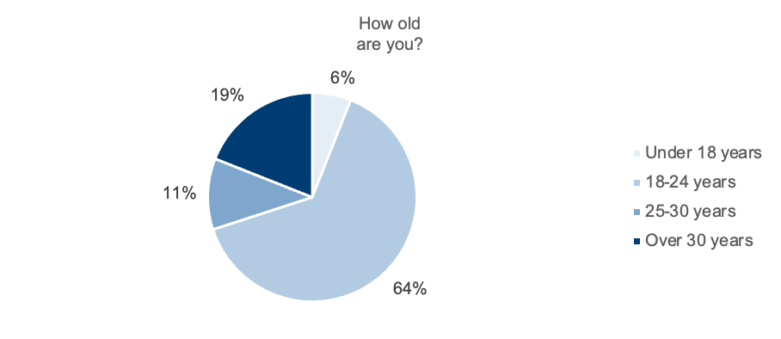
To obtain an overview of the participants, the first question was asked about the age of the participants. The participants were divided into four age categories. In total, six people under the age of 18, 64 people between the ages of 18 and 24, 11 people between the ages of 25 and 30, and 19 people over the age of 30 took part in the survey.
Figure 5.2. Overview German Population 2022
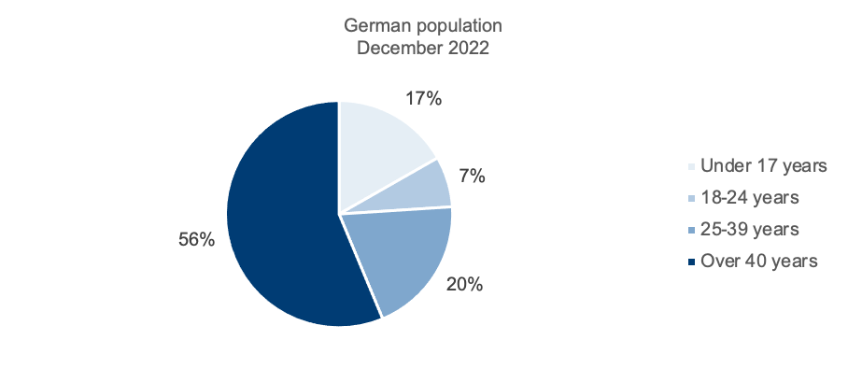
From the results presented, it is clear that the present sample does not represent the entire German resident population, as the proportion of older generations in the German population is significantly larger. In 2022, the proportion of Germany's inhabitants who were over 40 years old was 56 percent (Statista, 2023a). In the survey, exclusively 19 out of 100 persons were interviewed who were over 30 years old. At the same time, the age groups from 18 to 24 years represented a proportion of 64 percent in this survey. It should be emphasized that this age group only accounts for a share of 7 percent in Germany, the lowest among the groups considered (Statista, 2023b).
Question 2
Figure 5.3. Evaluation of question 2
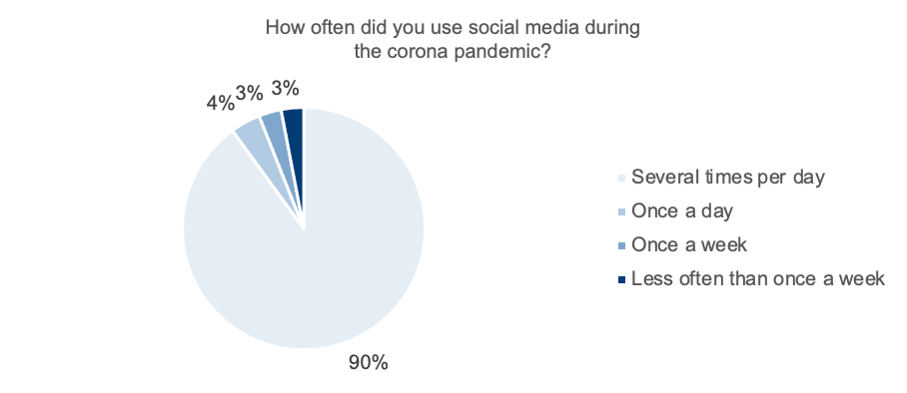
The second question surveyed the frequency with which social media was used during the corona pandemic. Here, 90 percent of respondents indicated that they used social media several times a day. Additionally, four percent used social media once a day, while three percent each reported using it either weekly or less frequently than once a week. It is significant to note that those survey participants who did not use social media several times a day were all over the age of 30.
Question 3
Figure 5.4. Evaluation of question 3
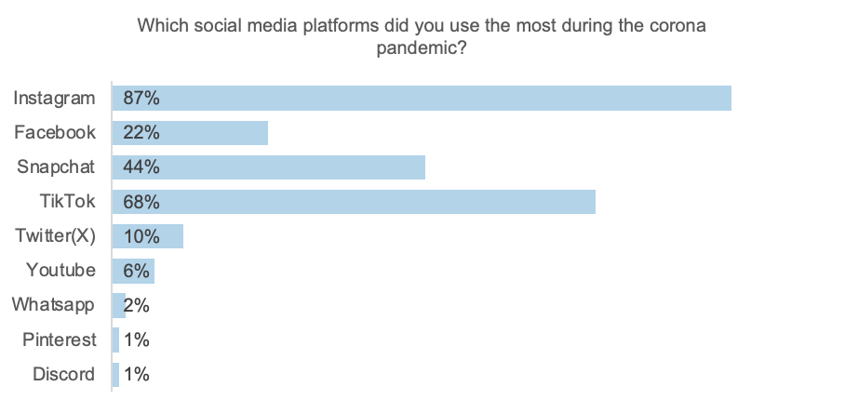
The third question referred to the preference regarding the use of different platforms, of which several options were available. In addition, it was possible to enter additional social media platforms on the questionnaire, as it was not possible to list all platforms due to the large number of existing platforms (cf. chapter 2.3.1).
The given platform Instagram received the highest rating with a total of 87 percent. The second most frequently used platform is TikTok with 68 percent. Snapchat was then chosen by 44 percent, while Facebook was preferred by 22 percent. Use of Twitter (X) was cited by ten percent. Other platforms, including YouTube (six mentions), WhatsApp (two mentions), Pinterest (one mention) and Discord (one mention), were also mentioned.
Question 4
FIGURE 5.5. EVALUATION OF QUESTION 4
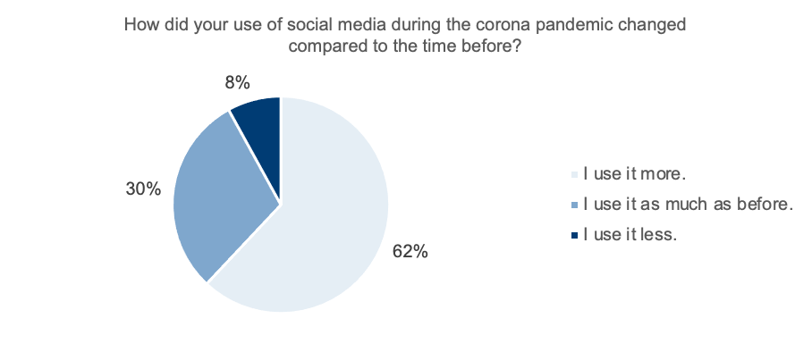
In the fourth question, a personal opinion survey was conducted to determine whether the use of social media had been influenced during the corona pandemic. More than half of the respondents stated that they had increased their use of social media compared to the time before the pandemic. A percentage of 30 percent of participants noticed no change and used social media in the same way as before. In contrast, 8 percent stated that they have been using social media less intensively since the corona pandemic.
The reduction in social media usage among certain individuals could be linked to the trending topic of 2022, with numerous people realizing that a lot of time was being lost due to the intensive usage of smartphones. For this reason, a particularly large number of people decided to take a Digital Detox during 2022. An online study by ARD and ZDF showed that almost half of those respondents had already taken a digital timeout, while more than a third had such plans for the future (Himmler & Hager, 2022, p. 34).
Question 5
FIGURE 5.6. EVALUATION OF QUESTION 5
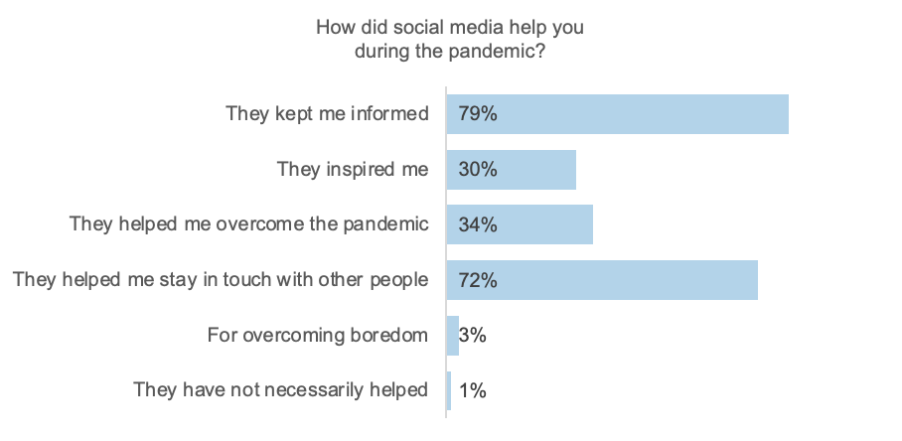
In the fifth question the survey respondents were asked about the overall degree to which social media was supportive during the corona pandemic and the main purpose for which it was used.. This information is valuable for identifying effective crisis management practices and potential areas of improvement. Four-fifths of the respondents stated that these platforms helped to keep them updated on current events. Three-quarters of the survey respondents said social media helped them to stay in touch with others. Thirty-four percent expressed that using social media helped them to cope with the pandemic, with 30 percent saying they were inspired by these platforms. Three individuals used the free response option to indicate that they used social media to combat boredom. One person expressed the view that social media was not necessarily helpful.
Question 6
FIGURE 5.7. EVALUATION OF QUESTION 6
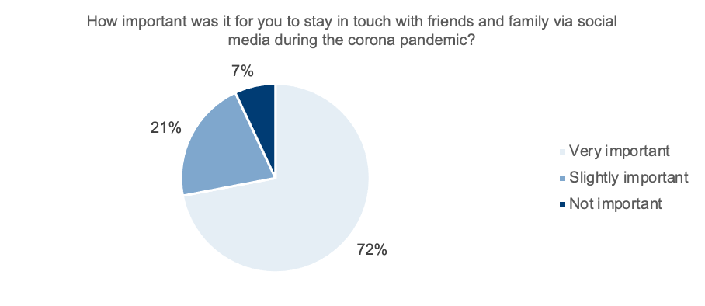
Since social media serves as a communication tool, the following question asked participants to rate the importance of social media during the corona pandemic for contact with friends and family. For 72 percent of the 100 respondents, social media contact was of high importance. One-fifth said it had some importance, while seven percent of participants felt it was less important.
Question 7
FIGURE 5.8. EVALUATION OF QUESTION 7
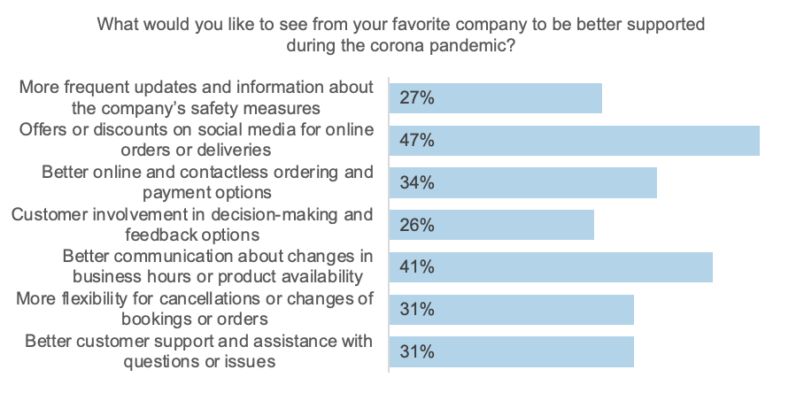
The seventh question aimed to capture what social media users expected companies to provide during the pandemic period. This question included predefined response options and likewise offered the option to add an additional response, which was not used in this case. Nearly half of survey participants expressed a desire for increased offers or discounts on social media platforms related to online ordering or delivery services. In addition, 41 percent expressed a need for improved communication regarding any changes. For 34 percent, an expanded selection of online ordering and payment options that minimize contact was also important. Similarly, 31 percent expressed a desire for streamlined customer service and support for inquiries or problems, as well as increased flexibility for cancellations or adjustments to bookings or orders. For 27 percent, the desire was for more regular updates and information on the company's security measures. A quarter of respondents expressed a desire to be more involved in decisions and to have multiple feedback options.
Question 8
FIGURE 5.9. EVALUATION OF QUESTION 8
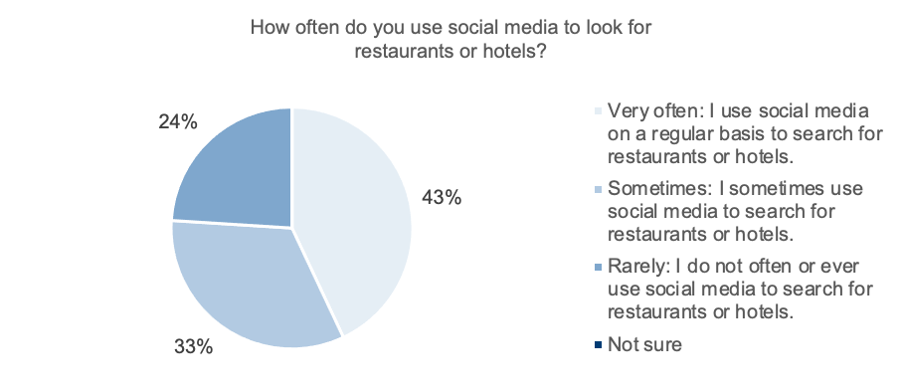
The eighth question examined whether people also search for hospitality offers within social networks. The participants were asked whether they search for restaurants or hotels on social media. The vast majority of respondents regularly search for restaurants or hotels on social media. More specifically, 76 percent search either very frequently or occasionally. In contrast, 24 percent of participants rarely or never use social media to search for restaurants or hotels.
Question 9
FIGURE 5.10. EVALUATION OF QUESTION 9
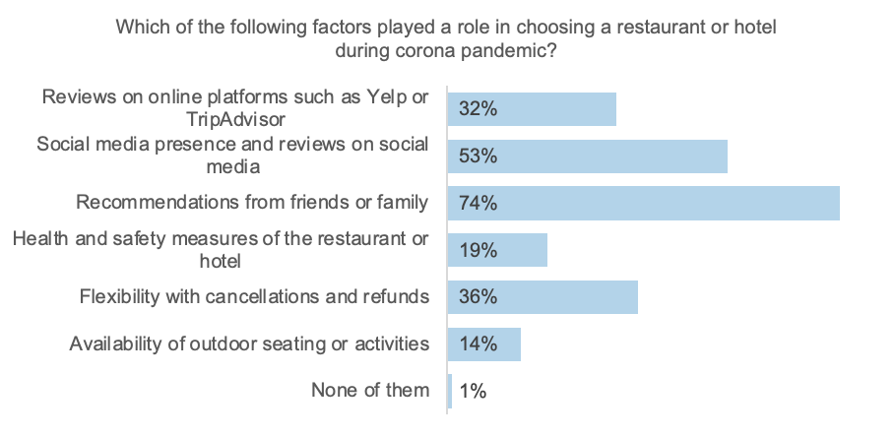
In the ninth question, the aim was to identify the factors that played a significant role for customers in choosing restaurants or hotels during the corona pandemic. In this regard, 74 percent of participants selected the factor of recommendations from friends or family. The second most significant factor was presence on social media, as well as reviews on those platforms, which received over 50 percent of the votes. Flexibility in terms of cancellations and refunds was voted as the third most important aspect, with a total of 36 percent. Ratings on online platforms received 32 percent of the votes. Health and safety measures garnered 19 percent of the votes, and availability of outdoor seating or activities garnered 14 percent. One person used the option of a free response to indicate that none of these factors played a role.
Question 10
FIGURE 5.11. EVALUATION OF QUESTION 10
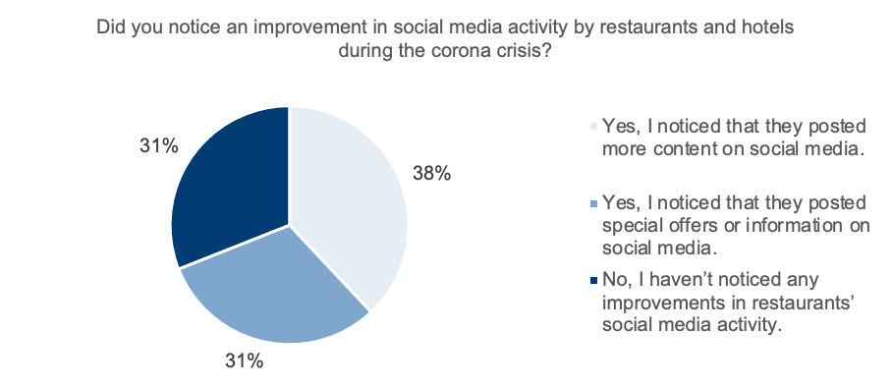
The final question aimed to gain insights from the hospitality target group on whether they noticed an increase in social media activity from restaurants and hotels during the corona crisis. A percentage of 38 percent of participants noted an increase, with more content being used on the social media profiles of restaurants and hotels. Similarly, 31 percent reported noticing changes in each case, whether through providing special offers or information, as well as sharing such. In parallel, 31 percent noticed no significant change in the activity on the social media channels of restaurants and hotels. It is of relevance to note that those participants who did not notice any change not only had an age of over 30, but many were also represented in the 18 to 24 age range. This illustrates that the lack of perception of change is not necessarily due to a low familiarity with social media.
5.2 Results of the qualitative interviews with experts
This section includes the interpretations of the interviews conducted. First, the interviewees are briefly introduced. Then the interviews will be analyzed individually following the categorization grid described in 4.1.2. The categorization is based on the following aspects:
● Social media
● Corona crisis
5.2.1 Interview 1
The interviewed interviewee Verena Heemann is co-owner of the restaurant Heemann in Hamburg. The restaurant is characterized by a seasonally oriented kitchen philosophy that focuses on the use of exclusively regional products. The selection of Heemann Restaurant for the purpose of this research interview was predicated on its unique opening circumstance, as it commenced its operations subsequent to the initial COVID-19 lockdown. This particular timing rendered Heemann Restaurant an insightful and relevant subject for study, as it provided a real-world case study in the context of the pandemic's impact on the hospitality industry.
Figure 5.12. Lars Heemann and Verena Heemann – Owners of Heemann (photo: Verena Heemann)

Social media:
The Heemann created an Instagram account for the company shortly before the opening to promote the restaurant. In doing so, the company pursued the goal of creating awareness and communicating news. Nevertheless, Verena Heemann increasingly recognizes the importance and potential of Facebook. However, there is a lack of expertise. The restaurant does not pursue a collaboration with an agency, and Verena Heemann carries out social media activities independently. Assessments of success are kept relatively minimal, as there are no clear goals or key performance indicators (KPIs) for the company that are tracked and evaluated. Verena Heemann recognizes the future importance of social media and emphasizes that changes are also needed at the restaurant Heemann.
Corona crisis:
The Heemann Restaurant opened after the first corona lockdown, so it was of major importance to promote the restaurant and establish its presence. In the beginning, there was cooperation with various city magazines and poster advertising to achieve greater awareness. The second lockdown made it difficult to communicate with customers. To keep the contact, they introduced picnic- and dinner-boxes, which were very successful only because of Instagram advertisements. Aside from social media and Google My Business updates, Heemann had almost no other options for target the audience communication. An online store was integrated into the website but was later eliminated.
5.2.2 Interview 2
The interview partner Christoph Meyer is co-owner of the Unikat hookah lounge in Gifhorn. Because of the COVID-19 pandemic, a temporary closure of the bar was necessary. In spring 2023, the owners had a new start and opened a new location.
Figure 5.13. Christoph Meyer, Lukas Lehrach and Cengiz Aktas – Owners of Unikat Lounge (photo: Christoph Meyer)
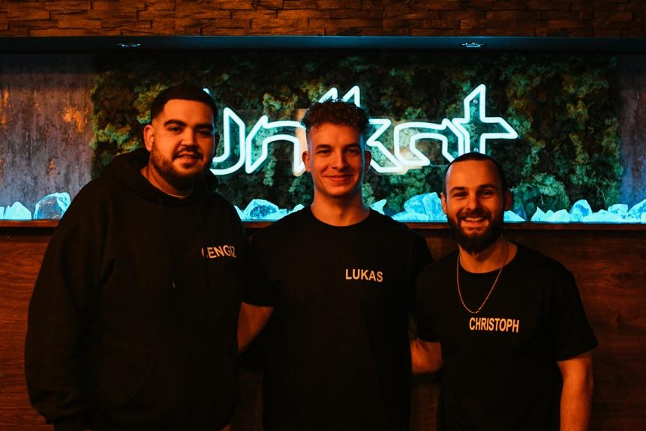
Social media
Unikat is currently running an Instagram as well as a Facebook account. Since they moved to the new location, these channels have been professionally managed by an agency. In the future, Christoph Meyer plans to be more present on TikTok as well. The bar does not have its own website and therefore only uses social media to receive reservations. Unikat's increased activity on social media resulted in more new visitors from other cities taking notice. Furthermore, Christoph Meyer recognizes the change in the increased usage of social media by the new generations.
Corona crisis
As already mentioned, the corona crisis led to a new start for the Unikat company. As a result of the lockdowns, direct communication with guests was no longer possible. Consequently, the owners were temporarily restricted to only sell drinks, and later, with one-way hookah pipes, they could sell hookahs. These measures led to the fact that the customer frequency decreased strongly. The operators made more phone calls to the familiar customers to communicate information and changes, which required an immense effort.
5.2.3 Interview 3
The interview partners Martina Lepsy and Hans-Peter Lepsy are the owners of Lepsy's Fischrestaurant in Willich, which has already been in business for 17 years. The choice to study Lepsy's Fischrestaurant thus reflects an intention to draw from its rich history and accumulated wisdom as a means to contribute meaningfully to the broader discourse on the challenges and opportunities facing restaurants in the time of crisis.
Figure 5.14. Martina and Hans-Peter Lepsy – Owners of Lepsy’s Fischrestaurant (photo: Martina Lepsy)
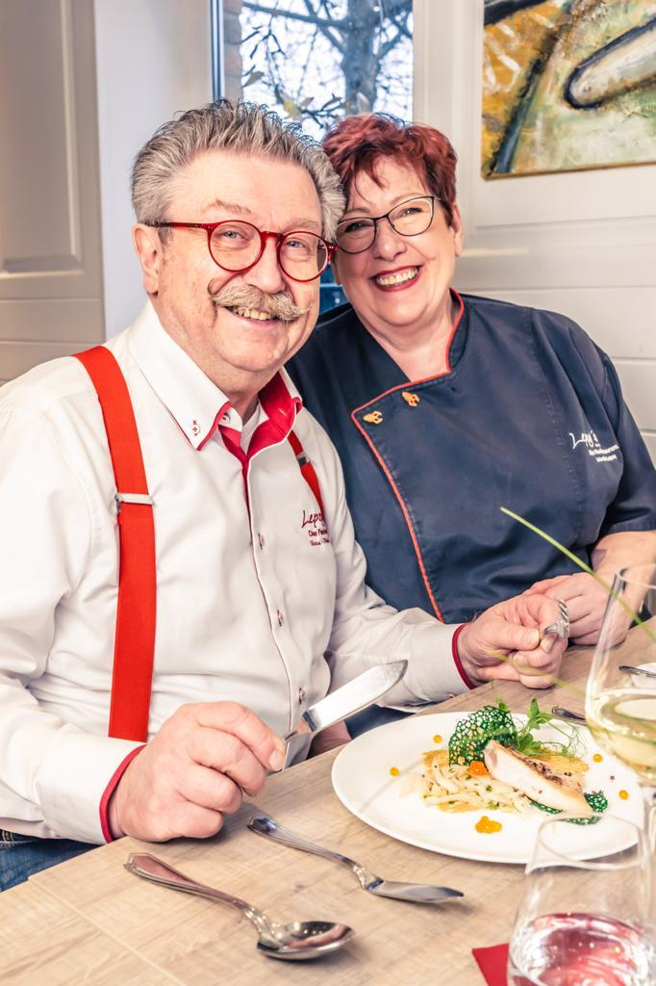
Social media
Lepsy's Fischrestaurant has been active on Instagram and Facebook for seven or eight years, using the support of an agency. The operators realized that newspaper advertisements were no longer effective, so they switched their marketing to social media. It became apparent that the audience of the restaurant has become much younger. Martina and Hans-Peter Lepsy evaluate the success of the social media presence by the number of reservations recorded through the online ordering and reservation function. In addition, email-newsletters have proven to be an effective way to keep frequent customers informed.
Corona crisis
During the lockdowns, the terrace business ran very successfully for a long time. The owners also introduced an out-of-home offering that was well received by their customers. Nevertheless, the restaurant lost about 25 percent of its guests due to the corona pandemic. For this reason, Martina and Hans-Peter Lepsy decided to downsize the restaurant and improve the kitchen, which at the same time helped solve the lack of staff availability and the cost pressures due to the reduced customers. Throughout the corona pandemic, communication was conducted exclusively through social media, with email marketing introduced later. The owners also noted that reservations and scheduling have been less predictable since corona crisis, with much of the customer base being more spontaneous since the pandemic.
5.2.4 Interview 4
The person interviewed, Timo Wiesel, is head of kitchen and marketing manager at the Grafschafter Wirtshaus in Moers, which opened in the summer of 2019. In addition to three Café Extrablatt locations, the Grafschafter Wirtshaus represents the fourth venture under the management of its owner, Stipe Madzar. The restaurant aims to appeal to an older audience by serving traditional German and regional cuisine. Since the foundation, the restaurant has consistently strived for digitalization and used numerous digital tools to optimize internal processes.
Social media
Shortly before opening, the Wirtshaus has actively operated Instagram and Facebook accounts to showcase its activities and reach a wide audience using them. In the meantime, these channels are also used to announce closing days on public holidays, for example, as this is noticed well by all guests. Timo Wiesel highlights that communication on Facebook has decreased and the tendency to Instagram is increasing. The restaurant works with an agency and its own photographers to ensure a professional presence. The Wirtshaus and Café Extrablatt branches have already focused heavily on social media for many years, and the operators and managers have learned a lot in this area and appreciate the effectiveness of this communication tool. Measuring success on social media is done by analyzing follower origins and interactions. Timo Wiesel characterized the success of social media in the restaurant with concrete measurable findings. As an example, he mentioned that although offering breakfast since the opening, awareness among guests was missing. The investment with a limited budget in social media advertising, however, resulted in a doubling of demand for breakfast. After the corona crisis, they again ran social media ads for breakfast and again saw a doubling of demand.
Corona crisis
The Wirtshaus responded quickly to the closures in the first lockdown by introducing a delivery service, distributing flyers, and improving its online presence through social media. The restaurant introduced the temporary preparation of burgers to compensate for the loss of sales at the three closed Café Extrablatt stores. This was an attempt to attract the target group of the three branches.
The restaurant responded to the lockdowns in three corresponding measures:
(1) Increasing capacity: The owner decided to rent a warehouse and convert it to create storage, office and cold storage capacity and build up reserves for one week at a time.
(2) Employee retention: During the corona crisis, the company placed special importance on keeping every employee, which was successfully accomplished.
(3) Improving social media presence: During the corona crisis, the success of social media communication could be measured extremely well. Timo Wiesel shared that the owner spontaneously decided to deliver pork shanks using only social media for advertising. This decision led to significant increase of sales.
Nevertheless, Timo Wiesel highlights that the impact of corona is still being felt and that it is being mixed with other current challenges, such as the Ukrainian war and inflation.
5.2.5 Interview 5
The interview partner Patrick Zengerling is co-owner of celerise GmbH, a Berlin-based marketing agency that is specialized in the hospitality industry. Since 2018, the company has been aiming to support hospitality businesses in the area of social media presence. Currently, the two owners manage a total of 30 restaurants across Germany.
Figure 5.15. Johann Weitzel and Patrick Zengerling – Owners of celerise GmbH (photo: Patrick Zengerling)

Social media
Patrick Zengerling emphasizes that conventional advertising strategies are limited and only offer local reach, while social media is not only scalable but can also be operated more cost-efficiently. But consistency and regular posting are of great importance. The agency highlights that frequent presence in the subconscious of the target audience promotes success, especially for sales. The agency recommends the optimal posting time is between 5 and 9 p.m. According to celerise GmbH, the optimal time to start using social media is now, as competition on social media is increasing and it is becoming more difficult to generate reach and to stand out. Patrick Zengerling also recommends starting with TikTok as early as possible to be a pioneer in this upcoming industry. In the end, the agency recommends being present where the target group is today, but above all where it will be in the future, and that will be online.
Corona crisis
The importance of social media as a communication tool was particularly demonstrated during the corona pandemic. Patrick Zengerling described it as the only way to communicate at the time, as almost everyone was at home and other marketing options were extremely limited. However, not every business had this understanding of the importance of social media. The restaurant and hotel industries, which were one of the first industries that had to shut down, began to realize the importance of social media. Companies suddenly became awake to the fact that without social media, personal communication based on regular guests alone is not sufficient for economic success. Especially for restaurants that targeted a group between 50 and 70 years old, it was observed that those stayed longer at home due to the corona crisis. In this situation, it was necessary to diversify the customer base, with increased efforts to appeal to younger generations. Patrick Zengerling emphasizes that social media is not only for entertainment but can also be used to build a personal bond and consequently customer loyalty. In particular, during the corona pandemic, it was noted that people were more active on social media and interacted more. The agency noted the failure that during times when the restaurant industry is experiencing shortages, marketing is often the first place to cut budget, even though this is the process that should actually be strengthened during this time to attract new customers to the restaurant.
6 Discussion
In order to analyze the relevance of social media for the hospitality industry in terms of crisis, a quantitative and qualitative social research was conducted. In the quantitative survey, 100 customer respondents were surveyed regarding their use of social media and their behavior within these platforms during the corona crisis.
The results of the quantitative survey showed that 90 percent of the respondents used social media multiple times a day. During the corona crisis, Instagram and TikTok were the most popular platforms, whereas these platforms belong to the network platforms (cf. chapter 2.3.1). The use of social media has increased, with 62 percent of the respondents saying they use social media more frequently since the pandemic. In addition, 76 percent use social media to research the hospitality industry often or sometimes. The social media presence of hospitality companies was an important factor in selecting a company for more than half of the respondents. In addition, 69 percent noted increased use of social media by hospitality companies during the corona crisis.
It is important to consider, this research did not cover all generations equally with regard to the percentages of the average population in Germany. With the inclusion of additional sample participants from the older generation, the results regarding the use of social media would possibly differ or not be as significant (statistical relevance). A recommendation for further research approaches is therefore to conduct a study with a higher number of subjects (to ensure the population) and with the inclusion of the older generations, alternatively to ensure that a population similar to the statistical survey is covered. Especially in order to determine the statistical significance, whether the use of social media there leads to similar results as in the present study.
In the qualitative social research, four expert interviews were conducted with hospitality companies that had made it through the corona crisis and are using social media. There was also an expert interview with a social media agency specializing on the hospitality industry.
The results of the qualitative expert interviews highlight the following key points:
● Gastronomes recognized the increased use of social media and believe it is the future of communication. (cf. chapter 5.2.1, chapter 5.2.2, chapter 5.2.5)
● In the corona crisis, social media proved to be a crucial communication tool, especially when personal contact was reduced (cf. chapter 5.2.1, chapter 5.2.3, chapter 5.2.5). Traditional marketing methods proved to be less effective (cf. chapter 5.2.3)
● In contrast to traditional marketing, social media offers more scalable opportunities to achieve greater reach and be more cost effective (cf. chapter 5.2.5). The use of social media, especially on platforms like Instagram, led to new guests from other cities visiting the bars and restaurants (cf. chapter 5.2.2).
● Social media is not only for entertainment, but can also help build customer loyalty and retention, which is a current goal in the hospitality industry (cf. chapter 5.2.5).
● Most companies focused mainly on Instagram and Facebook, with companies advertising on Facebook clearly experiencing the transition to Instagram (cf. chapter 5.2.2, chapter 5.2.3, chapter 5.2.4).
● The hospitality industry recognized the importance of social media for marketing during the crisis and is expected to rely on it more in the future, especially as the target audience becomes younger (cf. chapter 5.2.3, chapter 5.2.4, chapter 5.2.5).
For the qualitative expert interviews, it should be noted, this research is based exclusively on the personal assessments of the interviewees. For a more precise analysis of the results, additional statistical data from the companies, as well as a much higher number of interviews from the different areas, would be required to clearly confirm statistical significance.
7 Conclusion
The aim of this scientific research was to evaluate the relevance of social media for hospitality in terms of crisis in a scientific context and, if possible, to prove that the relevance is justified. This paper aimed to provide hospitality organizations and social media agencies with guidance on the necessity of using social media during and after times of crisis, while also providing insights into user behavior. It also provides insights into the internal operations of hospitality companies that are using social media as a communication tool.
A methodology was developed that included quantitative social research followed by qualitative social research in the form of expert interviews.
In the quantitative and qualitative social research, the following results crystallized as positive:
● The survey covered the future target audience, which is spending an increased amount of time online, highlighting the growing importance of social media.
● The hospitality industry is seeing an increase in the use of social media as it recognizes its future in this platform (both in usage and number of users). This increase is largely driven by Generations Z and Alpha. Although it is not always immediately obvious, it is expected to continue to grow.
● A significant majority (76 percent) of the target group frequently or occasionally searches for hospitality information on social media (cf. chapter 5.1 - Question 8). Over half of the respondents consider the presence of hospitality companies on social media to be a decisive factor in their selection of the company in question.
● Almost 70 percent of the respondents noticed a clearly positive change in the hospitality industry's social media presence since the beginning of the corona pandemic (cf. chapter 5.1 - Question 10). This demonstrates the increased understanding of the economic and social benefits of social media in the hospitality industry.
● During the lockdowns, social media proved to be the most important communication tool, especially when personal contact had to be heavily minimized. Social media functioned as an effective communication channel to keep in touch with customers and therefore to be successful and to sustain the basis of the company, at least in some parts of the business.
The following optimization potential has been identified during the data analysis:
In the survey, a small percentage of the population (approximately 8 percent) noted a slight decline in social media usage since the outbreak of the corona crisis as well (cf. chapter 5.1 - Question 4).
This revelation underscores that a substantial portion of the population recognized the extent of their digital media consumption during this period, prompting efforts to incorporate phases of digital detox. This evolving phenomenon presents a spectrum of possibilities and associated pitfalls, thus warranting a more comprehensive investigation. Another aspect concerned the time frame for conducting this scientific research, which meant that the mentioned limitations had to be considered.
In addition, the following advanced research approaches emerge:
(1) Identifying the relevance of social media in close sectors, e.g. Catering and Food Services, Event Management and Venues, Travel and Tourism
(2) Analysis of the importance of social media in previous crises
This research exclusively examined the hospitality industry. It would be important to analyze the relevance of social media in terms of crisis in other industries as well, in order to uncover trends, parallelisms or differences. Furthermore, it would be important to ensure the ongoing profitability and thereby the survivability of the various corporate divisions, or, if necessary, to identify support processes and use them in terms of business continuity. Besides, this research only considered the corona crisis, although it would be useful to statistically analyze future crises in addition to the past crises.

References
Beierwaltes, A., & Gonsior, K. (2014). Stichproben-Verfahren in der Umfrageforschung - Eine Darstellung für die Praxis (2th ed.). Springer VS.

Boelmann, J. M. (2018). Empirische Forschung in der Deutschdidaktik - Band 2: Erhebungs- und Auswertungsverfahren. Schneider Verlag Hohengehren GmbH.

Die Bundesregierung. (2020, March 22). Regeln zum Corona-Virus. https://www.bundesregierung.de/breg-de/leichte-sprache/22-maerz-2020-regeln-zum-corona-virus-1733310

Dresing, T., & Pehl, T. (2012). Praxisbuch Interview & Transkription - Regelsysteme und Anleitungen für qualitative ForscherInnen (4th ed.).

Gläser, J., & Laudel, G. (2010). Experteninterviews und qualitative Inhaltsanalyse (4th ed.). VS Verlag für Sozialwissenschaften.

Himmler, N., & Hager, F. (2022). ARD ZDF Onlinestudie 2022. ARD & ZDF. https://www.ard-zdf-onlinestudie.de/files/2022/ARD_ZDF_Onlinestudie_2022_Publikationscharts.pdf

Kaufmann, S. (2021). Schülervorstellungen zu Geradengleichungen in der vektoriellen Analytischen Geometrie. Springer Spektrum.
Kuckartz, U. (2010). Einführung in die computergestützte Analyse qualitativer Daten (3rd ed.). VS Verlag für Sozialwissenschaften.

Kuckartz, U. (2016). Qualitative Inhaltsanalyse - Methoden, Praxis, Computerunterstützung (3rd ed.). Beltz Juventa.

Lorenz, R. K. (2021). Krisen erfolgreich meistern - Als Unternehmens-Quadriga gemeinsam erfolgreich Krisen verhindern und managen (1st ed.). Haufe-Lexware GmbH & Co. KG.

Mayring, P. (2002). Einführung in die qualitative Sozialforschung (5th ed.). Beltz.

Mayring, P. (2008). Qualitative Inhaltsanalyse: Grundlagen und Techniken (10th ed.). Beltz.

Raehlmann, I. (2022). Corona-Pandemie – die Folgen für die Arbeits- und die Alltagswelt. Springer VS.

rnd. (2022a). RedaktionsNetzwerk Deutschland - Folge der Pandemie: Steigende Zahl an Gastronomie-Betrieben von Pleite bedroht. www.rnd.de. https://www.rnd.de/panorama/gastronomie-insolvenzen-in-corona-krise-steigende-zahl-an-betrieben-von-pleite-bedroht-NBLBACDNMZPELD6B7N4CYBHSRY.html#:~:text=Die%20Zahl%20der%20finanzschwachen%20und,der%20Gastronomie%20in%20Deutschland%20erwartet.&text=Frank

rnd. (2022b). RedaktionsNetzwerk Deutschland - Mehr als jeder zweite Betrieb in Existenznot: Gastgewerbe fordert neue Perspektiven. www.rnd.de. https://www.rnd.de/panorama/gastgewerbe-jeder-zweite-betrieb-in-existenznot-dehoga-fordert-neue-perspektiven-MPEBW2JU4NDWDNOV6JHGZSWWLE.html

Statista. (2023a). Anzahl Infektionen und Todesfälle in Zusammenhang mit dem Coronavirus (COVID-19) in Deutschland seit Februar 2020. www.statista.com. https://de.statista.com/statistik/daten/studie/1102667/umfrage/erkrankungs-und-todesfaelle-aufgrund-des-coronavirus-in-deutschland/#professional

Statista. (2023b). Bevölkerung - Verteilung der Einwohner in Deutschland nach relevanten Altersgruppen am 31. Dezember 2022. www.statista.com. https://de.statista.com/statistik/daten/studie/382409/umfrage/verteilung-der-bevoelkerung-deutschlands-nach-altersgruppen/

Wittkowski, J. (1994). Das Interview in der Psychologie - Interviewtechnik und Codierung von Interviewmaterial (1st ed.). VS Verlag für Sozialwissenschaften.
Open Access Agreement
This article is published under a CC BY 4.0 license. This license allows reusers to distribute, remix, adapt, and build upon the material in any medium or format, so long as attribution is given to the creator. The license allows for commercial use. For more information, please visit
https://creativecommons.org/licenses/by/4.0/

Corresponding Author
The corresponding author for this manuscript is Anna Maria Wantoch-Rekowski who can be contacted by email via annawantoch@gmx.de and Prof. Dr. Petyo Budakov who can be contacted by email via p.budakov@xu-university.de.

